PROJECT SUBMISSION ( CODES AND OUTPUTS )

Code Imported on Google Colab with libraries :

import pandas as pd
import matplotlib.pyplot as plt
import matplotlib.patches as mpatches
import seaborn as sns
import warnings
warnings.filterwarnings('ignore')
from google.colab import files
uploaded = files.upload()

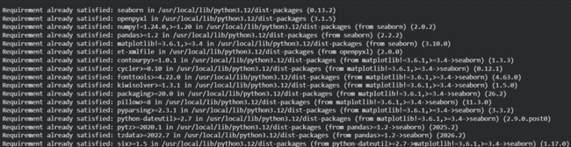
pip install seaborn openpyxl

# LOAD & CLEAN DATA
df = pd.read_excel('Power BI Updated Data analyst Data (1).xlsx')
# Clean column names
df.columns = df.columns.str.strip()
# Clean text columns
df['Leadership- skills'] = df['Leadership- skills'].str.strip().str.lower()
df['Family Income'] = df['Family Income'].str.strip()
# Map Family Income to numeric midpoints for correlation
income_map = {'0-2 Lakh': 1, '2-5 Lakh': 3.5, '5-7 Lakh': 6, '7 Lakh+': 8}
df['Family Income Numeric'] = df['Family Income'].map(income_map)
# Colour palette
COLORS = ['#4361ee', '#f72585', '#4cc9f0', '#7209b7', '#3a0ca3',
'#f3722c', '#90be6d', '#43aa8b', '#577590', '#f8961e']
sns.set_style("whitegrid")
print("=" * 60)
print(" CLOUD COUNSELAGE GPI — DATA ANALYSIS SOLUTIONS")
print("=" * 60)

(A) BASIC QUESTIONS (Attempt any 8):

- How many unique students are included in the dataset?
CODE :
unique_students = df['Email ID'].nunique()
print(f"\n Unique students in dataset: {unique_students}")
CONCLUSION : ( Colab Output )


CONCLUSION : ( Tableau Output )
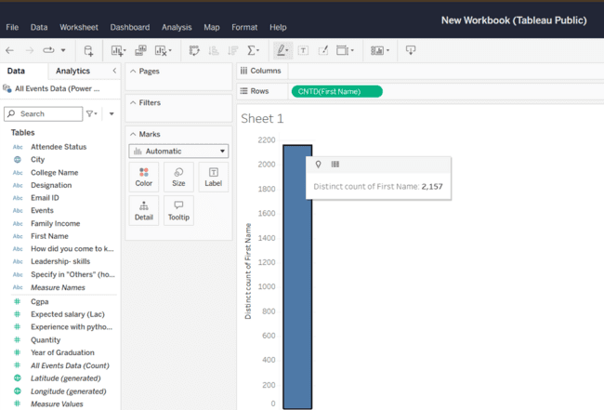

- What is the average GPA of the students?
CODE :
avg_gpa = df['CGPA'].mean()
print(f"\n Average GPA of students: {avg_gpa:.2f}")
CONCLUSION :(Colab Output )

Tableau Output :

- What is the distribution of students across different graduation years?
CODE :
grad_dist = df['Year of Graduation'].value_counts().sort_index()
print(f"\n Distribution by Graduation Year:\n{grad_dist.to_string()}")
fig, ax = plt.subplots(figsize=(8, 5))
bars = ax.bar(grad_dist.index.astype(str), grad_dist.values, color=COLORS[:len(grad_dist)], edgecolor='white', linewidth=0.8)
for bar in bars:
ax.text(bar.get_x() + bar.get_width()/2, bar.get_height() + 10,
str(int(bar.get_height())), ha='center', va='bottom', fontsize=10, fontweight='bold')
ax.set_title("Q3 — Students by Graduation Year", fontsize=14, fontweight='bold', pad=15)
ax.set_xlabel("Graduation Year"); ax.set_ylabel("Number of Students")
plt.tight_layout()
plt.show()

CONCLUSION : ( Colab Output )
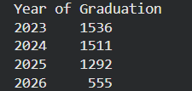
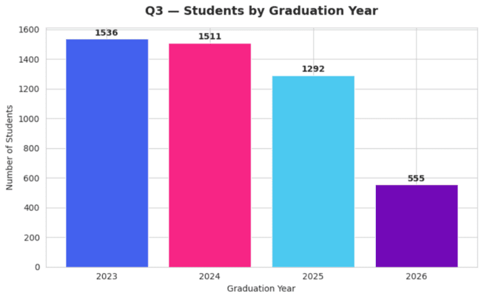
Tableau Output :
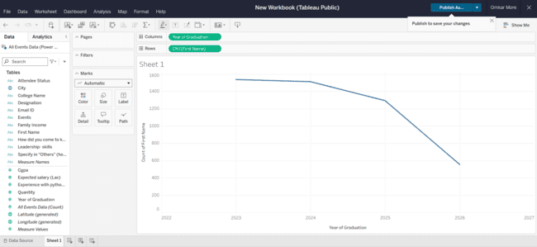
- What is the distribution of student's experience with Python programming?
CODE :
py_dist = df['Experience with python (Months)'].value_counts().sort_index()
print(f"\n Python Experience Distribution (months):\n{py_dist.to_string()}")
fig, ax = plt.subplots(figsize=(8, 5))
ax.bar(py_dist.index.astype(str), py_dist.values, color='#4361ee', edgecolor='white')
ax.set_title("Q4 — Python Experience Distribution (Months)", fontsize=14, fontweight='bold', pad=15)
ax.set_xlabel("Experience (Months)"); ax.set_ylabel("Number of Students")
plt.tight_layout()
plt.show()
CONCLUSION : ( Colab output )
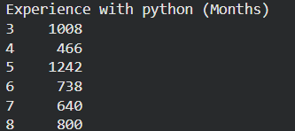
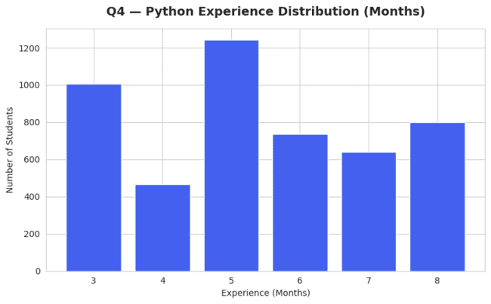
TABLEAU OUTPUT :
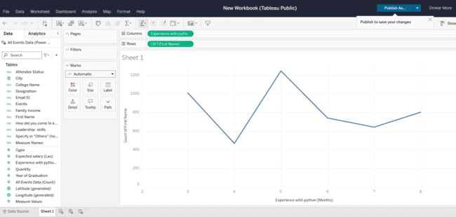
- What is the average family income of the student?
CODE :
income_dist = df['Family Income'].value_counts()
avg_income_num = df['Family Income Numeric'].mean()
print(f"\n Family Income Distribution:\n{income_dist.to_string()}")
print(f" Avg numeric income bracket midpoint: ₹{avg_income_num:.2f} Lakh")
CONCLUSION :
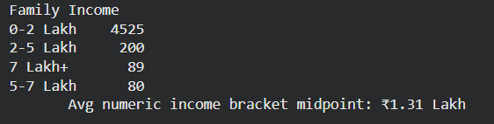
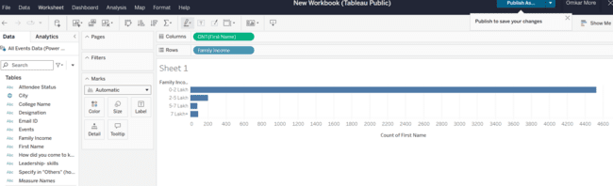
TABLEAU OUTPUT :

- How does the GPA vary among different colleges? (Show top 5 results only)
CODE :
top5_colleges = df.groupby('College Name')['CGPA'].mean().sort_values(ascending=False).head(5)
print(f"\nTop 5 Colleges by Avg GPA:\n{top5_colleges.to_string()}")

CONCLUSION : (Colab output )

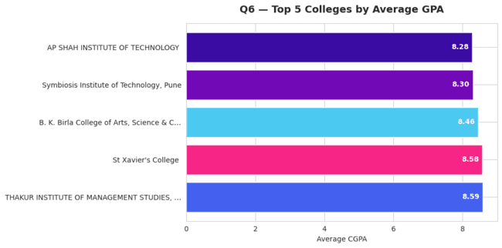
Tableau Output :
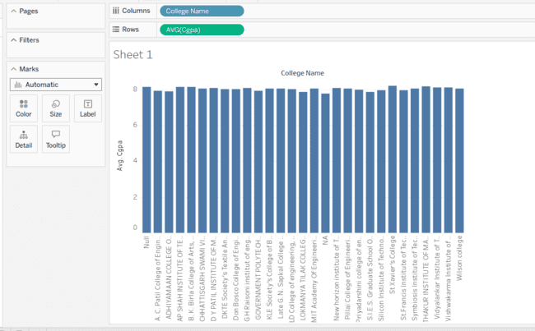
- Are there any outliers in the quantity (number of courses completed) attribute?
CODE :
Q1 = df['Quantity'].quantile(0.25)
Q3 = df['Quantity'].quantile(0.75)
IQR = Q3 - Q1
lower = Q1 - 1.5 * IQR
upper = Q3 + 1.5 * IQR
outliers = df[(df['Quantity'] < lower) | (df['Quantity'] > upper)]
print(f"\n Outlier Detection in Quantity:")
print(f" IQR = {IQR}, Lower bound = {lower}, Upper bound = {upper}")
print(f" Number of outliers: {len(outliers)}")
print(f" Outlier values: {outliers['Quantity'].unique()}")
fig, ax = plt.subplots(figsize=(6, 5))
ax.boxplot(df['Quantity'], patch_artist=True,
boxprops=dict(facecolor='#4361ee', color='navy'),
medianprops=dict(color='yellow', linewidth=2),
flierprops=dict(marker='o', markerfacecolor='#f72585', markersize=6))
ax.set_title("Q7 — Boxplot: Quantity (Courses Completed)", fontsize=13, fontweight='bold', pad=15)
ax.set_ylabel("Quantity")
plt.tight_layout()
plt.show()
CONCLUSION :
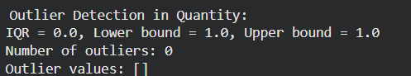
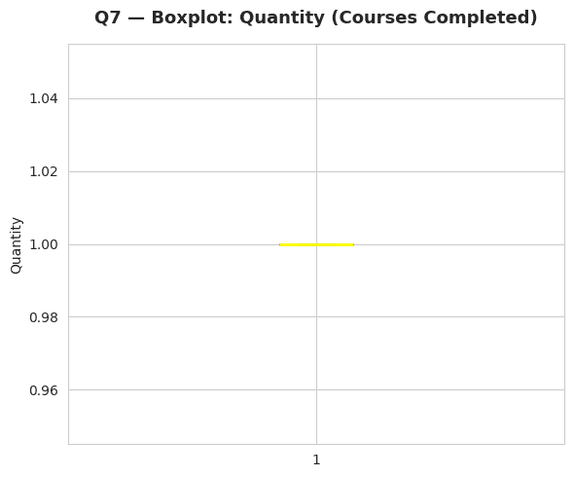
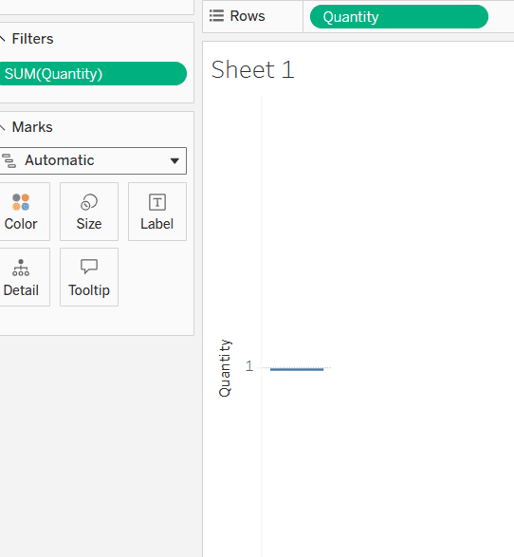
- What is the average GPA for student from each city?
CODE :
city_gpa = df.groupby('City')['CGPA'].mean().sort_values(ascending=False).head(10)
print(f"\n Average GPA by City (Top 10):\n{city_gpa.to_string()}")
fig, ax = plt.subplots(figsize=(10, 5))
bars = ax.bar(city_gpa.index, city_gpa.values, color=COLORS, edgecolor='white')
for bar in bars:
ax.text(bar.get_x() + bar.get_width()/2, bar.get_height() - 0.3,
f'{bar.get_height():.2f}', ha='center', va='top', color='white', fontsize=9, fontweight='bold')
ax.set_title("Q8 — Avg GPA per City (Top 10)", fontsize=14, fontweight='bold', pad=15)
ax.set_xlabel("City"); ax.set_ylabel("Average CGPA")
plt.xticks(rotation=30, ha='right')
plt.tight_layout()
plt.show()
CONCLUSION : Colab Output :

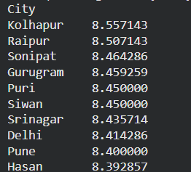
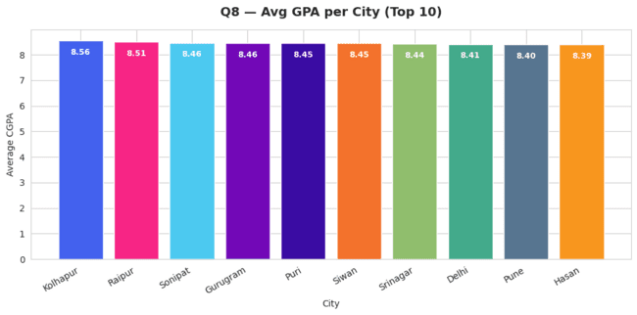
Tableau Output :
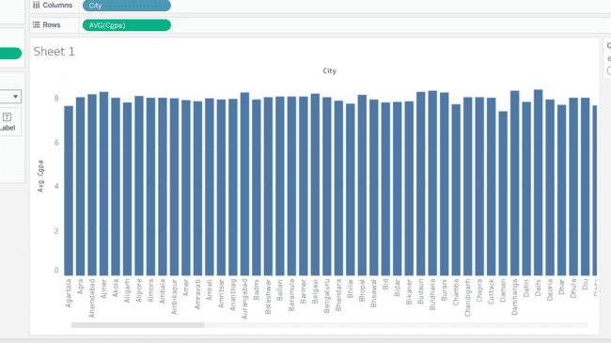
- Can we identify any relationship between family income and GPA?
CODE :
corr = df[['Family Income Numeric', 'CGPA']].corr().iloc[0, 1]
print(f"\n Correlation between Family Income & GPA: {corr:.4f}")
print(f" Interpretation: {'Weak' if abs(corr) < 0.3 else 'Moderate' if abs(corr) < 0.6 else 'Strong'} {'positive' if corr > 0 else 'negative'} correlation")

fig, ax = plt.subplots(figsize=(8, 5))
income_gpa = df.groupby('Family Income')['CGPA'].mean().reindex(['0-2 Lakh', '2-5 Lakh', '5-7 Lakh', '7 Lakh+'])
bars = ax.bar(income_gpa.index, income_gpa.values, color=COLORS[:4], edgecolor='white')
for bar in bars:
ax.text(bar.get_x() + bar.get_width()/2, bar.get_height() - 0.3,
f'{bar.get_height():.2f}', ha='center', va='top', color='white', fontweight='bold')
ax.set_title(f"Q9 — Avg GPA by Family Income (Corr: {corr:.3f})", fontsize=13, fontweight='bold', pad=15)
ax.set_xlabel("Family Income"); ax.set_ylabel("Average CGPA")
plt.tight_layout()
plt.show()
print("\n" + "=" * 60)
print(" MODERATE QUESTIONS")
print("=" * 60)

CONCLUSION : Colab Output :
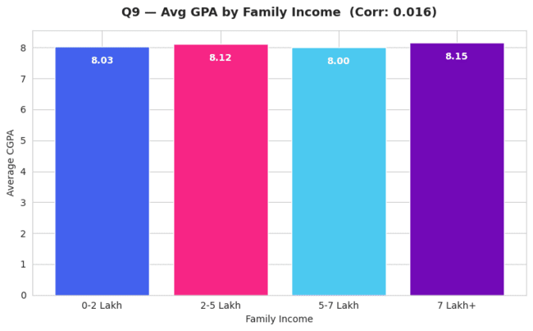
Tableau Output :
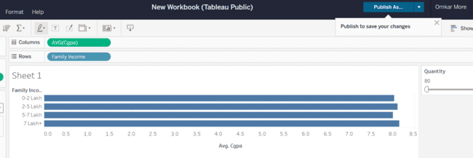

(B) MODERATE QUESTIONS (Attempt any 8):

- How many students from various cities? (Solve using data visualisation tool)
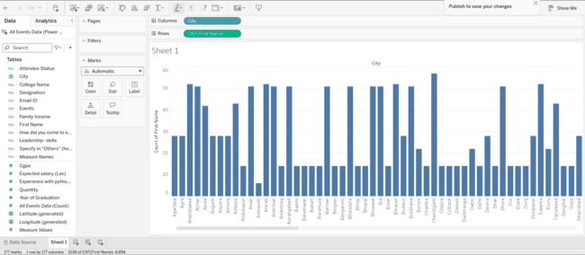
CONCLUSION : ( BY USING TABLEU PUBLIC TOOL USED FOR DATA VISUALIZATION)

CODE : ( on Google Colab only top 15 cities )
city_counts = df['City'].value_counts().head(15)
print(f"\n Top 15 Cities by Student Count:\n{city_counts.to_string()}")
fig, ax = plt.subplots(figsize=(10, 6))
sns.barplot(x=city_counts.values, y=city_counts.index, palette='Blues_r', ax=ax)
for i, v in enumerate(city_counts.values):
ax.text(v + 1, i, str(v), va='center', fontsize=9, fontweight='bold')
ax.set_title("Q10 — Students from Various Cities (Top 15)", fontsize=14, fontweight='bold', pad=15)
ax.set_xlabel("Number of Students"); ax.set_ylabel("City")
plt.tight_layout()
plt.show()
CONCLUSION : ( ON GOOGLE COLAB ) :

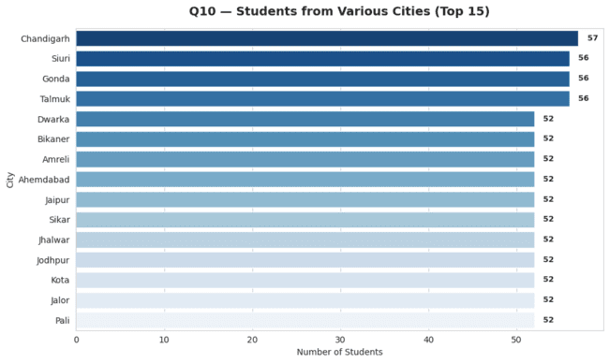
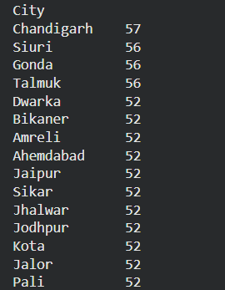

- How does the expected salary vary based on factors like 'GPA', 'Family income', 'Experience with Python (Months)'?
CODE :
print(f"\n Expected Salary vs Key Factors:")
corr_gpa_sal = df[['CGPA', 'Expected salary (Lac)']].corr().iloc[0, 1]
corr_inc_sal = df[['Family Income Numeric', 'Expected salary (Lac)']].corr().iloc[0, 1]
corr_py_sal = df[['Experience with python (Months)', 'Expected salary (Lac)']].corr().iloc[0, 1]
print(f" GPA vs Expected Salary correlation: {corr_gpa_sal:.4f}")
print(f" Family Income vs Expected Salary correlation: {corr_inc_sal:.4f}")
print(f" Python Exp vs Expected Salary correlation: {corr_py_sal:.4f}")
fig, axes = plt.subplots(1, 3, figsize=(15, 5))
for ax, col, label, corr_val, color in zip(
axes,
['CGPA', 'Family Income Numeric', 'Experience with python (Months)'],
['CGPA', 'Family Income (Numeric)', 'Python Experience (Months)'],
[corr_gpa_sal, corr_inc_sal, corr_py_sal],
['#4361ee', '#f72585', '#4cc9f0']
):
ax.scatter(df[col], df['Expected salary (Lac)'], alpha=0.15, color=color, s=10)
ax.set_xlabel(label); ax.set_ylabel("Expected Salary (Lac)")
ax.set_title(f"Corr = {corr_val:.3f}", fontsize=11)
fig.suptitle("Q11 — Expected Salary vs Key Factors", fontsize=14, fontweight='bold', y=1.02)
plt.tight_layout()
plt.show()
CONCLUSION :
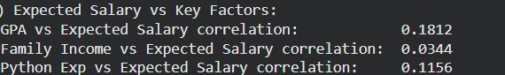
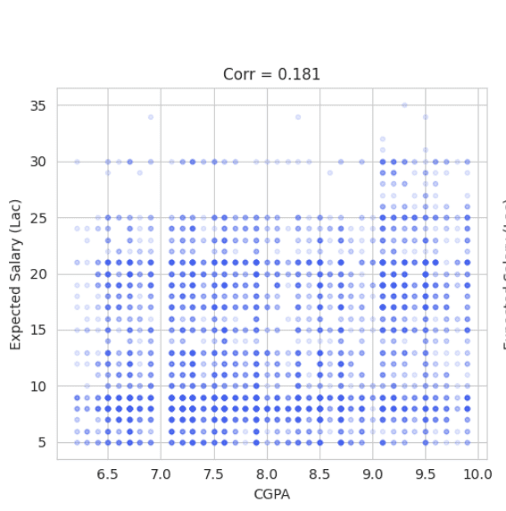
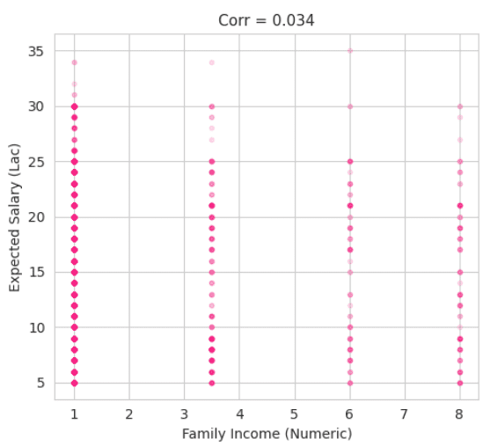

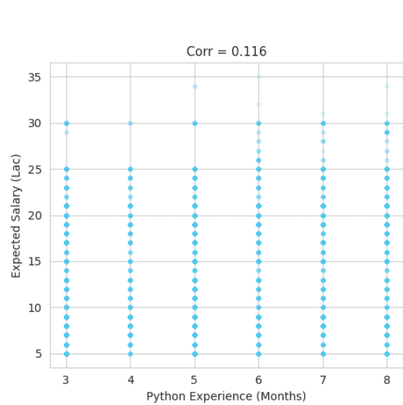
Tableau Output :
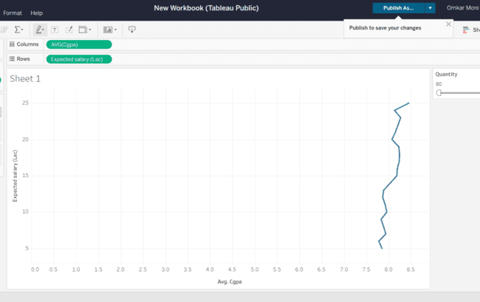

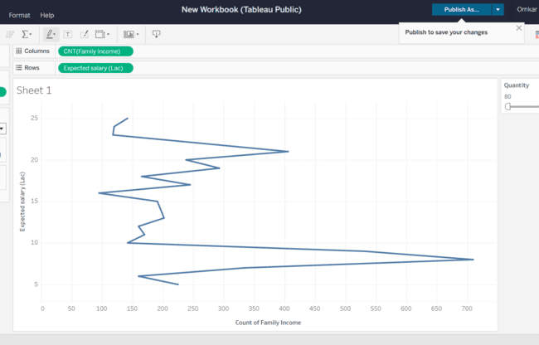
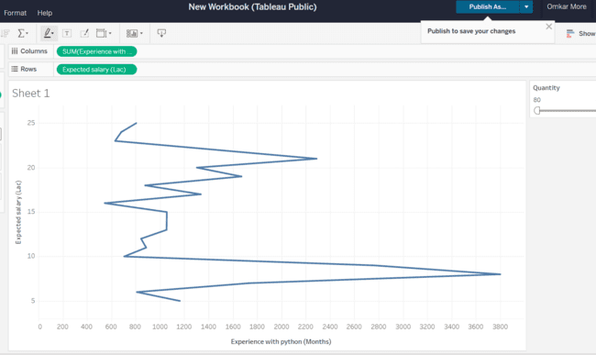

- Which event tend to attract more students from specific fields of study?
CODE :
event_college = df.groupby('Events')['College Name'].nunique().sort_values(ascending=False)
print(f"\n Events by number of unique colleges:\n{event_college.to_string()}")
fig, ax = plt.subplots(figsize=(10, 6))
sns.barplot(x=event_college.values, y=event_college.index, palette='viridis', ax=ax)
ax.set_title("Q12 — Events vs Unique Colleges Attracted", fontsize=13, fontweight='bold', pad=15)
ax.set_xlabel("Unique Colleges"); ax.set_ylabel("Event")
plt.tight_layout()
plt.show()
CONCLUSION : Colab Output :
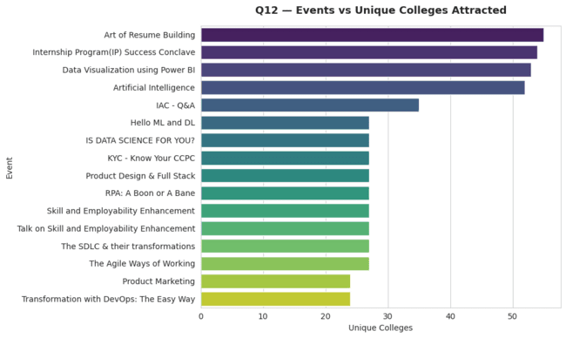
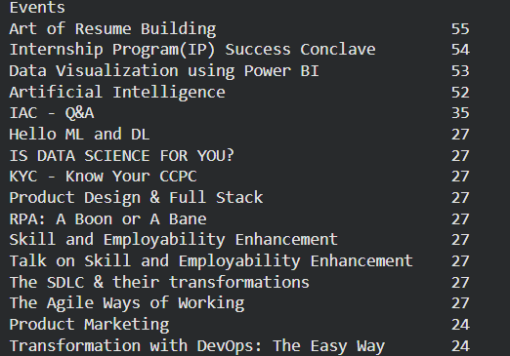
Tableau Output :
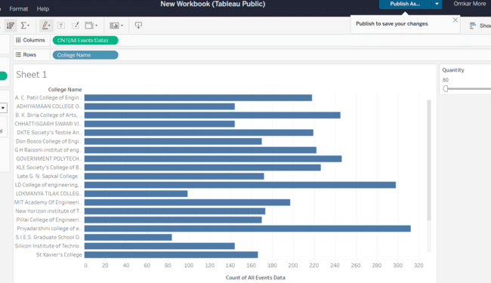
- Do students in leadership positions during their college years tend to have higher GPAs or better expected salary?
CODE :
leadership = df[df['Leadership- skills'].isin(['yes', 'no'])]
leader_gpa = leadership.groupby('Leadership- skills')['CGPA'].mean()
leader_sal = leadership.groupby('Leadership- skills')['Expected salary (Lac)'].mean()
print(f"\n Leadership Skills vs GPA & Salary:")
print(f" Avg GPA — Yes: {leader_gpa.get('yes', 0):.2f} | No: {leader_gpa.get('no', 0):.2f}")
print(f" Avg Salary — Yes: {leader_sal.get('yes', 0):.2f} | No: {leader_sal.get('no', 0):.2f}")
fig, axes = plt.subplots(1, 2, figsize=(10, 5))
for ax, data, title, color_pair in zip(
axes,
[leader_gpa, leader_sal],
['Avg CGPA', 'Avg Expected Salary (Lac)'],
[['#4361ee', '#f72585'], ['#4cc9f0', '#7209b7']]
):
bars = ax.bar(data.index.str.title(), data.values, color=color_pair, edgecolor='white')
for bar in bars:
ax.text(bar.get_x() + bar.get_width()/2, bar.get_height() - 0.3,
f'{bar.get_height():.2f}', ha='center', va='top', color='white', fontweight='bold')
ax.set_title(f"Q13 — Leadership vs {title}", fontsize=12, fontweight='bold')
ax.set_xlabel("Leadership Skills"); ax.set_ylabel(title)
fig.suptitle("Q13 — Leadership Skills Impact", fontsize=14, fontweight='bold')
plt.tight_layout()
plt.show()

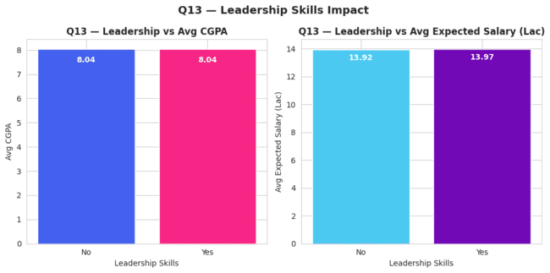
CONCLUSION : Colab Output :

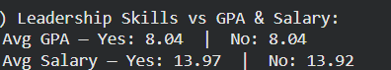

Tableau Output :
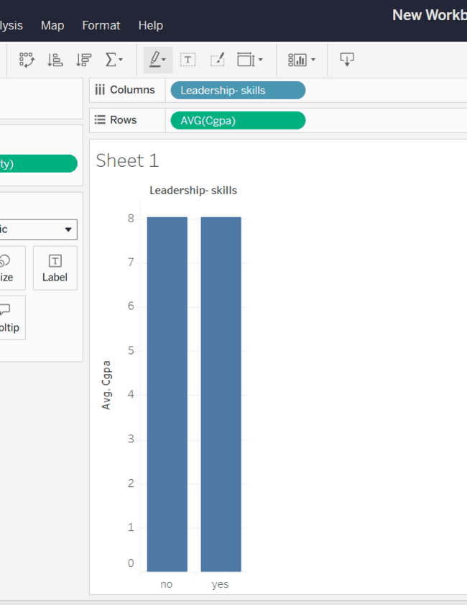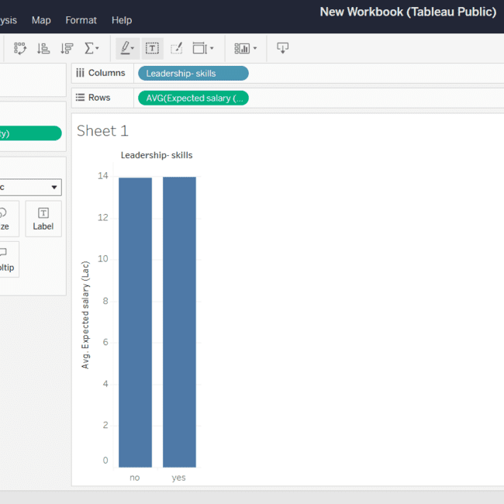
- How many students are graduating by the end of 2024?
CODE :
graduating_2024 = df[df['Year of Graduation'] <= 2024]['Email ID'].nunique()
print(f"\n Unique students graduating by end of 2024: {graduating_2024}")
CONCLUSION :
Tableau Output :
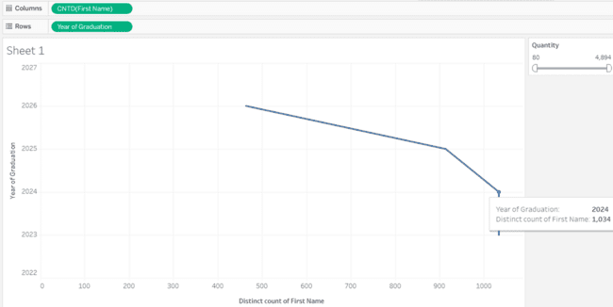
- Which promotion channel brings in more student participations for the event?
CODE :

CONCLUSION :
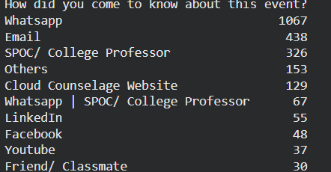
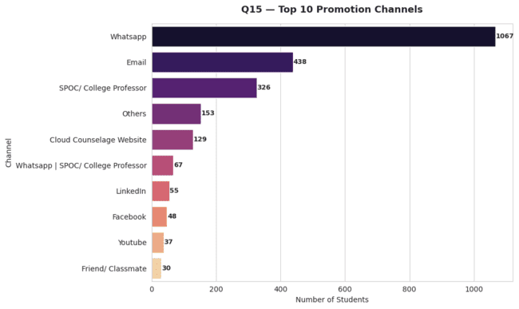
Tableau Output :
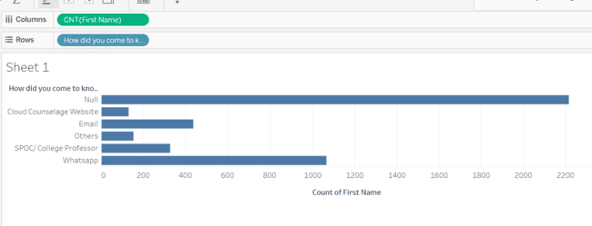
- Find the total number of students who attended the events related to Data Science? (From all Data Science related courses)
CODE :
ds_keywords = ['data science', 'data visualization', 'hello ml', 'artificial intelligence']
ds_mask = df['Events'].str.lower().apply(lambda e: any(kw in e for kw in ds_keywords))
ds_students = df[ds_mask]['Email ID'].nunique()
ds_event_counts = df[ds_mask]['Events'].value_counts()
print(f"\n Total unique students in Data Science related events: {ds_students}")
print(f" Events counted:\n{ds_event_counts.to_string()}")

CONCLUSION : Colab Output :
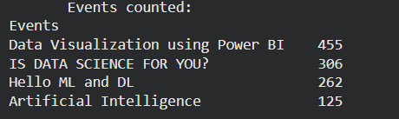
Tableau Output :
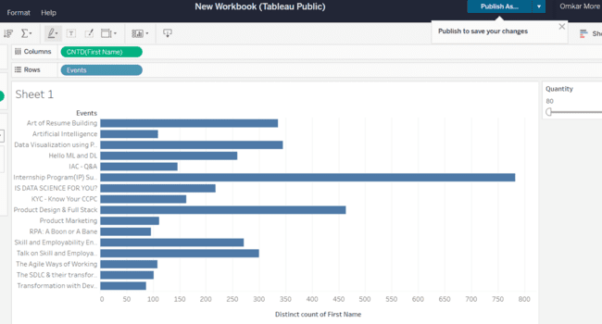
- Those who have high CGPA & more experience in language — those who had high expectations for salary? (Avg)
CODE :
cgpa_median = df['CGPA'].median()
py_median = df['Experience with python (Months)'].median()
high_performers = df[(df['CGPA'] >= cgpa_median) & (df['Experience with python
(Months)']>= py_median)]
avg_salary_hp = high_performers['Expected salary (Lac)'].mean()
overall_avg = df['Expected salary (Lac)'].mean()
print(f"\n High CGPA (≥{cgpa_median}) & High Python Exp (≥{py_median} months):")
print(f" Count: {len(high_performers)}")
print(f" Avg Expected Salary: ₹{avg_salary_hp:.2f} Lac")
print(f" vs Overall Avg Salary: ₹{overall_avg:.2f} Lac")
print(f" Difference: ₹{avg_salary_hp - overall_avg:.2f} Lac more")
fig, ax = plt.subplots(figsize=(6, 5))
categories = ['All Students', 'High CGPA +\nHigh Python Exp']
values = [overall_avg, avg_salary_hp]
bars = ax.bar(categories, values, color=['#4361ee', '#f72585'], edgecolor='white', width=0.4)
for bar in bars:
ax.text(bar.get_x() + bar.get_width()/2, bar.get_height() - 0.3,
f'₹{bar.get_height():.2f}L', ha='center', va='top', color='white', fontsize=12, fontweight='bold')
ax.set_title("Q17 — Salary: High Performers vs All", fontsize=13, fontweight='bold', pad=15)
ax.set_ylabel("Avg Expected Salary (Lac)")
plt.tight_layout()
plt.show()
print("\n" + "=" * 60)
print("=" * 60)

CONCLUSION :
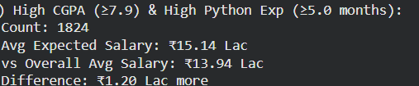
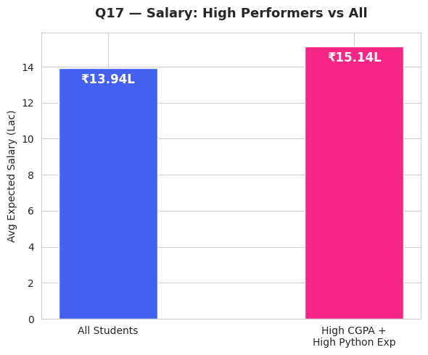
Tableau Output :
